**CLOUDANT-DB**

**Creating service instance**

|  |  |
| --- | --- |
| Date | 19 September 2022 |
| Team ID | PNT2022TMID27630 |
| Project Name | VirtualEye - Life Guard for Swimming Pools to Detect Active Drowning |
| Maximum Marks | 4 Marks |

**Step 1:** *Open the IBM cloud website. In the Resource list page, under Services click Cloudant-g4.You’ll be redirected to a new page, click Launch Dashboard.*

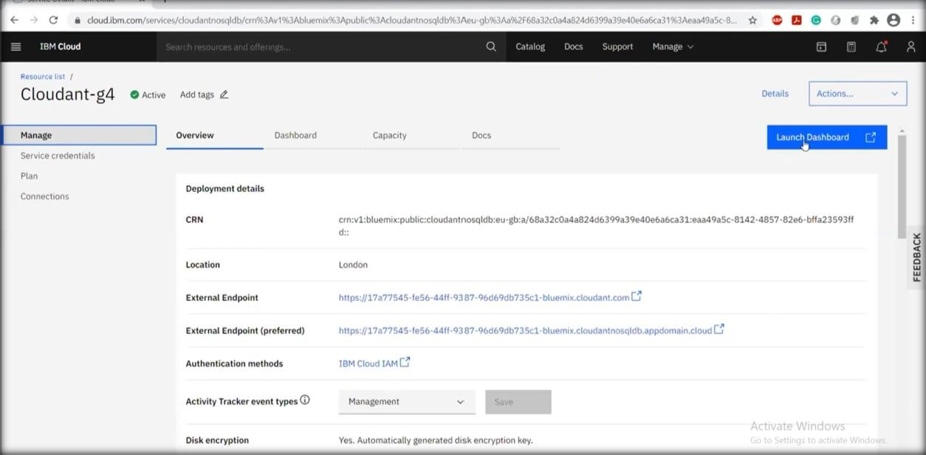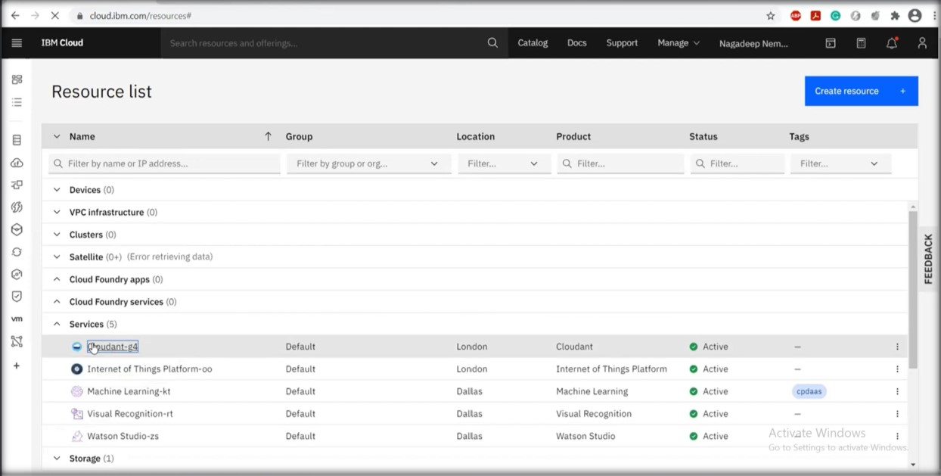

**Step 2:** *You’ll be redirected to databases page. Provide a database name and select partitioned and then select create. Then click*

*create document.*

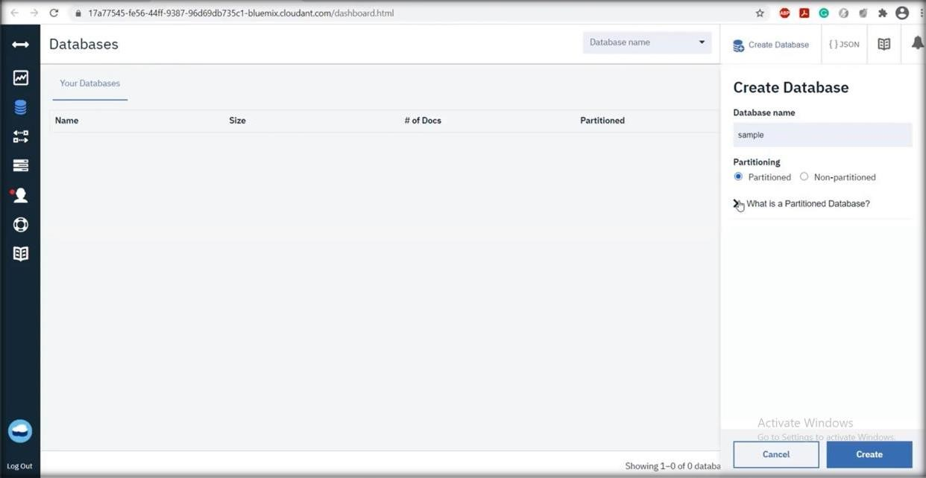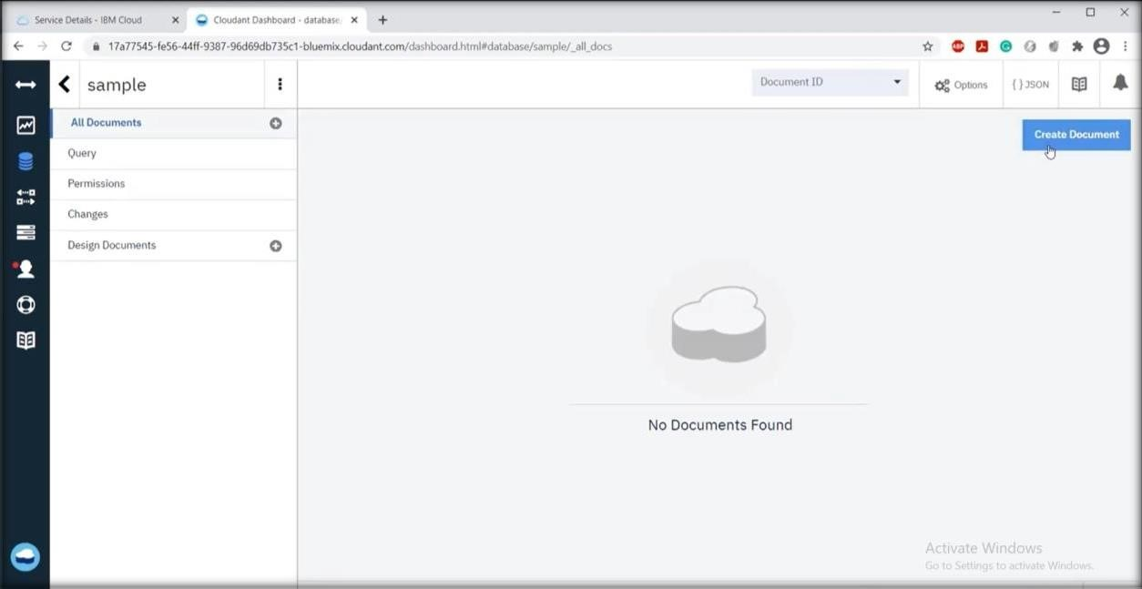

**Step 3:** *A new page will appear with id. Enter your database and create.*

